T517 NASA Lunar Landing Payload Crane Offloading Validation
Alanna Black Jayson Dickinson
Christina Morrow Ryker Mullinix
FAMU-FSU College of Engineering, 2525 Pottsdamer St, Tallahassee, FL 32310
In 2017, NASA introduced the Artemis missions with a goal of building a base on the moon. The team at Langley Research Center created a crane that will land on the moon attached to their Peregrine lander and unload the cargo. After unloading, the crane lowers onto a rover. The rover and crane combination will set up the lunar base before astronauts arrive.
Team 517 designed a machine that lowers this crane from the moon lander to the rover. NASA uses popular acronyms when naming projects, so our design is called the ARROW (Automated and Ranged Relocation Of the crane for Wider application). The idea comes from Artemis’ role in Greek mythology as the goddess of the hunt. Her symbols are the bow and arrow.
The design considers several constraints given to our team. This includes a weight limit, doing tasks free from outside control, and scaling for different crane sizes. The constraints allow the team to create a working design in the time given. Our team was successful in meeting these goals by keeping the weight below 20 pounds, making the ARROW scalable for any size, and enabling to the ARROW to work by itself. Our calculations were based on the mini crane.
Our ARROW supports the crane and rotates it off the Peregrine lander to position it onto the rover. The base of the ARROW uses a motor and gears to rotate the crane 90 degrees. The top half uses another motor pinned to a plate. The plate mates with the crane and angles it down towards the ground. The crane uses supplied power from the plate to lower itself to the rover. The ARROW can scale for different crane sizes, meaning our design’s use extends to multiple missions.
- Nomenclature
ARROW = Automated and Ranged Relocation Of the LSMS for Wider application
CAD = Computer Aided Design
CLPS = Commercial Landing Payload Services
DC = Direct Current
EVA = Extra-Vehicular Activity
LSMS = Lightweight Surface Manipulation System
LED = Light Emitting Diode
NASA = National Aeronautics and Space Administration
RGB = Red Green Blue
DR6 = Design Review 6
- Introduction
- Project Description
NASA, partnered with CLPS, has developed an autonomous means of payload transportation to operate on the lunar surface, called the LSMS. This project is concerned with offloading the LSMS from the CLPS lander, so that it may be used for a wider range of tasks. This is necessary for establishing a lunar presence and building the foundation for future missions to Mars. NASA wants to create a means of building a base at one of the poles on the Moon and develop a method of rapid assembly of the base. To do this, the LSMS must be relocated onto a mobile platform. This will be done with a design called the ARROW.
- Project Objective
The objective of this project is to offload the LSMS from the CLPS lander onto a platform on the lunar surface.
- Key Goals
A key goal is to design the ARROW to be capable of off-loading the LSMS. Making this a key goal is a direct result of the customer statement regarding the project requirements.
Another key goal of this project is to design the ARROW to be scalable for any size LSMS. In the virtual simulation there should be a 1:1 lifting capability to weight ratio for the ARROW relative to each LSMS size. There should be the ability to create ARROWs of various sizes so that money can be saved in the creation of smaller models and a prototype can be delivered to the customer that works exactly as the final product would work. This allows for potential issues to be addressed prior to the creation of the final product assembly.
The final key goal is for the ARROW to be completely autonomous with human control being activated fail-safes. The machine or mechanism would operate without any human intervention needed. Keeping the ARROW completely autonomous also means it must be able to communicate with other devices on the lander if the design is not completely mechanical.
- Assumptions
Some assumptions were made to narrow the scope of the teams’ efforts. It is assumed that the team is not responsible for transportation of the ARROW to the lunar surface and operation of the ARROW will take place on the moon. It is also assumed that the ARROW will be stationary, with access to power from the CLPS lander. Another assumption is that reusability of the ARROW is not a concern. Additionally, it is assumed that the LSMS will send a ready signal to the ARROW and the duties of the ARROW will occur as part of the automated landing sequence. It is also assumed that an existing end effector will be utilized, to increase time spent on other design aspects. The LSMS and ARROW locations on the lander are at the discretion of the design team and the LSMS can dock to the lunar platform. Environmental factors such as regolith and temperature changes are also assumed to not be a concern for this project design. It was also assumed that in-space and in-space EVA assembly will not be required. For the demonstration it was also assumed that the weight of the miniature LSMS is 25% of its lifting capability at the wrist.
- Targets and Metrics
- Motion System
Regarding the functions that fall under the Motion system, it is assumed that the LSMS is attached to the mounting deck of the Peregrine lander. Three targets were determined for the Relocate the LSMS function, each concerning a direction of motion. A translation of 0.525 meters is needed in the x-direction, 0.525 meters in the y-direction, and 1.069 meters in the z-direction. These targets are based on the dimensions of the Peregrine lander’s mounting deck and the height of the Chariot mobility chassis, which the LSMS will dock to.
Three targets were also developed for the Move about Axes function regarding the Motion system. These include an angular degree of motion of 0 to 180 degrees for the x and y axis and an angular degree of motion of 0 to 360 degrees about the z axis. This was determined because the design needs to have as many degrees of freedom as possible to account for whichever direction the ARROW must move to successfully transport the LSMS. These targets were determined to be the maximum degrees of rotation because when one axis is given a 360 degree of rotational freedom, the other two axes are physically constrained to 180 degrees of rotational freedom.
- Support System
Falling under the Support system is the Decrease Position Error function. A positioning tolerance for vertical and lateral misalignments of ± 2.54 centimeters and a ±10 degree positioning tolerance about a vertical axis (Doggett, 2011). The same value of ± 2.54 centimeters was chosen as the clearance target for the Release LSMS function. For the third support target, Secure LSMS, 41 N of grip force was established as a necessity for the ARROW fixing the LSMS before movement. Another function in the Support system, the Scale for Variable LSMS Size is one of the critical targets for the project. A scaling ratio of 1:1 has been set for this critical function.
- Power System
In the Power system of the targets and metrics, the Receive Power was determined to be up to 1800 Watts of power available for use. Based on the mass of the LSMS, weighing 55.1 lbs in Earth’s gravity, for the Convert Power to Torque function, 33 N*m was established to be the minimum torque that will be needed in transferring the LSMS onto the platform.
- Communication System
After discussions with the project sponsor, it was decided that powering the ARROW did not fall in the scope of this project. The power source is assumed to be a standard United States outlet, which provides 120 V. Based on this assumption, the target for the Transduce Signal function has been set to 120 Volts. A frequency of 2.4 GHz will be a target for receiving and transmitting signals. This target is based on the transmitter on the Peregrine which is 2.4 GHz (Astrobotic, 2020). The last function in the Communication system is the Process Signal, which has been given a target of 18 milliseconds. This is based on the average response time of an RC controller, which is an assumption given by the project sponsor regarding the communication ability of the LSMS.

- Results and Discussion
The following section outlines the methods of validation used and the percent error from those tests.
- Motion System
Targets for this system were validated by measuring the lander demonstration model. For movement about axes angles were measured using an electronic level. For measuring the distances required for LSMS movement, a tape measure was used. The table below shows the total measurements achieved by the ARROW.
Action | X-AXIS | Y-AXIS | Z-AXIS | Method of Validation
Move about Axes | 0 deg | 44 deg | 90 deg | Measuring via angle finder
Relocate LSMS | 0.57 m | 0.22 m | 1.07 m | Measuring with tape measure
Table 1: Motion System Validation
This table shows the targets of this system and their method of validation. The targets of this system were within 2.26% of intended.
- Support System
Targets for this system were validated through a combination of Creo simulation and physical measurements.
Action | Target |  | Method of Validation
Decrease LSMS Position Error | ±2.54 cm | ±10 deg | Measuring physical model
Secure LSMS | 41 N |  | Creo simulation
Release LSMS | ±2.54 cm |  | Written Procedure
Scale for Variable LSMS Size | 1:1 weight to lifting capability |  | Parts Specification
Table 2: Support System Validation
The table shown previously shows the targets for this system and their method of validation. The targets of this system were within <1% of intended. The next paragraph begins explaining the Creo Simulation used to validate securing the LSMS.
It was determined that the connection plate would need to be capable of withstanding a 41 N force. Figure 1 and 2, shown below, show the shear and internal stresses on the connection plate when a 41 N force is applied to it. This is representative of the force the plate needs to be able to handle to safely support the LSMS.
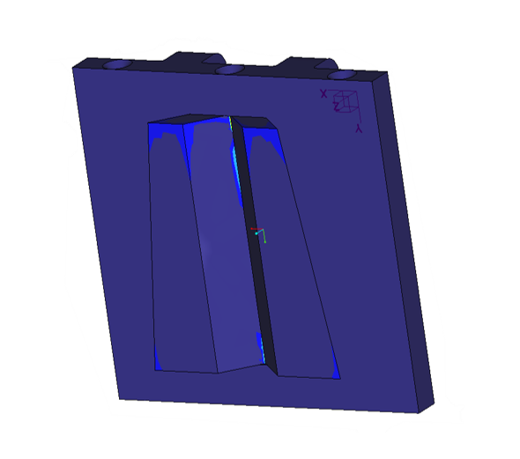
Fig. 1 Maximum Shear Stress
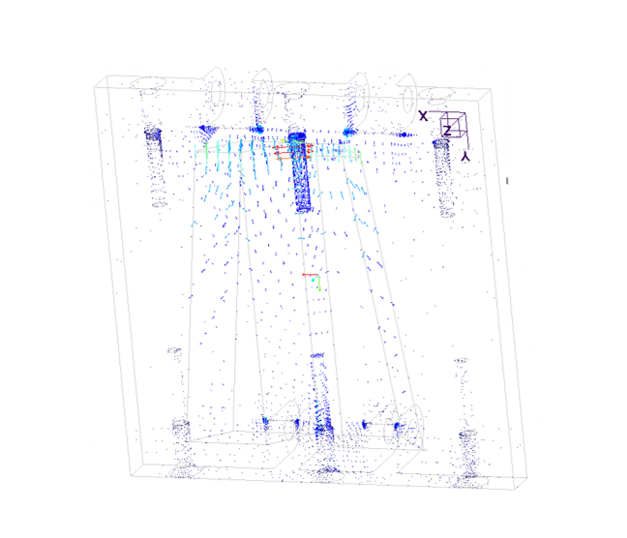
Fig. 2 Internal Stress
The highest concentration of stress is in the center of the dovetail cut at 6 MPa, far below the 207 MPa that the aluminum can handle. The internal stresses are at the threads of the screws but is considered nominal.
The position error final results found that the final location of the LSMS averaged to be 0.97 cm from center, below the 2.54 cm desired. The average vertical alignment was 2.75 deg, which is again below the desired 10 degrees. The closer to zero these alignments are, the better as it allows for greater accuracy and precision for the components. Had these results been too large, corrective measures would be taken in the code to allow for finer movements. Pictures of the validation are on slide 79 of DR6 (Mullinix, 2021).
- Power System
The power system was validated completely by the ARROW’s ability to rotate the LSMS model without problems and power on. This system can be accurately validated in the future by using a force measuring device to see the total amount of force the ARROW can lift before stall occurs. Another method of doing this would be to put a mass that it is known the ARROW cannot lift and have a scale under the weight. Once the ARROW tries to lift the mass, the change in weight can be calculated to see the total torque the ARROW can produce before failure.
Table 3, below, shows the targets and their respective methods of validation for the power system.

Action | Target | Method of Validation
Receive Power | 1800 Watts | Verifying power supply capabilities
Convert Power to Torque | 33 Nm | Demonstration model functionality
Table 3: Power System Validation
The targets of this system were within 0.26% of intended.
- Communication System
For communication, the ARROW successfully validated two of the four targets. The processing speed was measured to be 16 milliseconds, 2 milliseconds quicker than the desired number of 18 milliseconds. This was measured by recording the time it took for the ARROW to move after hitting the spacebar to simulate the LSMS sending the “ready” signal. Slide 82 of DR6 shows the video with timestamps. Transduce signal was validated by the ability to run off wall power. Transmit and receival of signal were not validated as the design did not incorporate Bluetooth. This can be implemented in future iterations of the ARROW.
Action | Target | Method of Validation
Transmit Signal | 2.4 GHz | N/A
Receive Signal | 2.4 GHz | N/A
Transduce Signal | 120 Volts | Verifying Power Supply Capabilities
Process Signal | 18 milliseconds | Timing video
Table 4: Communication System Validation
- Conclusion
The targets of this system were within 5% of intended. The ARROW successfully offloaded the LSMS as was shown in the validation portion of this paper. The final design weighed in at 18.7 pounds, or 8.5 kilograms. The offloading process is completely autonomous and can be scaled with few modifications.
- Errors
The model LSMS created by the team is a semi-accurate representation of NASAs actual crane. There is flexing of the wood, inadequacies in the distribution of the weight, and the joint connections are very different than the LSMS. Because of this, certain disparities are present in the demonstration and validation methods. To alleviate this, a better model of the crane should be developed or the actual miniature LSMS should be used for final testing. Other errors present are in the model of the payload deck. The model created does not feature the triangular pattern seen on the Peregrine Lander and so the attachment of the Quiver to the deck. The final Quiver should be designed to mount to the lander deck, but the overall design can stay the same.
- Future Work
The continuing stages of this project would go on to incorporate a space rated bill of materials, adhering to the standards that NASA has established regarding material selection. In that same vein, the environmental factors should be taken into consideration for the next design iteration. These environmental factors include, but are not limited to acceleration due to gravity, temperature ranges, and regolith. The design can be modified to improve resilience to this environment.
The next stage in the project, is to incorporate the LSMS power integration. One of the caveats of this project was that the LSMS can receive power via the wrist connection at the ARROW. This allows the LSMS to maneuver itself, while the base is disconnected. Developing this power connection is a crucial stage in seeing this project through to fruition.
Lastly, system integration is the final stage in the process. Incorporating the ARROW into the operating system of the Peregrine lander and developing the power connection between the two. The goal is to create a cohesive system that includes the lander, the ARROW, and the LSMS so that they can work in junction to achieve a common goal.
To aid in the scalability of the ARROW, certain design aspects should be changed. The lower module’s linear actuator and rack and pinion should be replaced with a motor driven worm gear. This would allow essentially infinite rack travel to keep the length of the ARROW to a minimum. The rest of the design could be utilized the same way, simply strengthen the material, increase the size of top linear actuator, and increase the strength of the gear train to allow for a smaller motor to be used to power the worm gear.
- Concluding Remarks
The successful offloading of the LSMS will allow for the lunar base setup in the Artemis to be completed. Without the crane being offloaded, the Artemis mission will fail because of the base being unable to be created prior to astronaut arrival on the moon. Team 517’s ARROW provides pivotal information into how the crane should be removed from the lander onto a rover on the lunar surface. The utilization of previous components developed by and available to NASA allows for this design to integrate easily into the Artemis mission near-seamlessly, with only a few changes to be able to have the design be space-ready.

Acknowledgments
Team 517 would like to acknowledge NASA’s Marshall Space Flight Center (MSFC) for the time, resources, and help they have provided to our team to be able to accomplish this. Specifically, we would like to give a big thanks to Rachel McCauley and Justin Rowe from MSFC and Tom Carno from NASA’s Langley Research Center. We would also like to give thanks to the FAMU-FSU College of Engineering for providing with some of the necessary resources to complete this design.

References

[1] Doggett, W.; Dorsey, J.; Jones, T.; King, B.; Mercer, C.; Brady, J., . . . Ganoe, G. (2011). Recent Developments in the Design, Capabilities and Autonomous Operations of a Lightweight Surface Manipulation System and Test-bed. AIAA SPACE 2011 Conference & Exposition. doi:10.2514/6.2011-7266
[2] PEREGRINE LUNAR LANDER: PAYLOAD USER’S GUIDE [PDF]. (2020, June). Astrobotic Technology.
[3] Mullinix, R. (2021). T517 Lunar Landing Payload Crane. Retrieved April 11, 2021, from https://web1.eng.famu.fsu.edu/me/senior_design/2021/team517/
[4] Doggett, W.; Dorsey, J.; Jones, T.; King, B.; Mikulas, M. (2008). Design and Field Test of a Mass Efficient Crane for Lunar Payload Handling and Inspection: the Lunar Surface Manipulation System. AIAA SPACE 2008 Conference & Exposition. doi:10.2514/6.2008-7635
[5] Doggett, W., Dorsey, J., Mikulas, M. (2008). Preliminary Structural Design Considerations and Mass Efficiencies for Lunar Surface Manipulator Concepts. AIAA SPACE 2008 Conference & Exposition. doi:10.2514/6.2008-7916
[6] Doggett, W.; Dorsey, J.; Jones, T.; King, B.; Mikulas, M.; Roithmayr, C. (2009). Developments to Increase the Performance, Operational Versatility and Automation of a Lunar Surface Manipulation System. AIAA SPACE 2009 Conference and Exposition. doi:10.2514/6.2009-6795
[7] Angster, S.; Caldwell, D.; Chrone, J.; Doggett, W.; Dorsey, J.; Haddad, M.; Helton, D.; Jefferies, S.; Jones, T. (2010). Lunar Lander Offloading Operations Using a Heavy-Lift Lunar Surface Manipulator System. AIAA SPACE 2009 Conference and Exposition. doi:10.2514/6.2010-8804

Robotics and Controls Engineer, Mechanical Engineering.
Geometric Integration Engineer, Mechanical Engineering.
Design and Test Engineer, Mechanical Engineering.
Materials Engineer, Mechanical Engineering.

